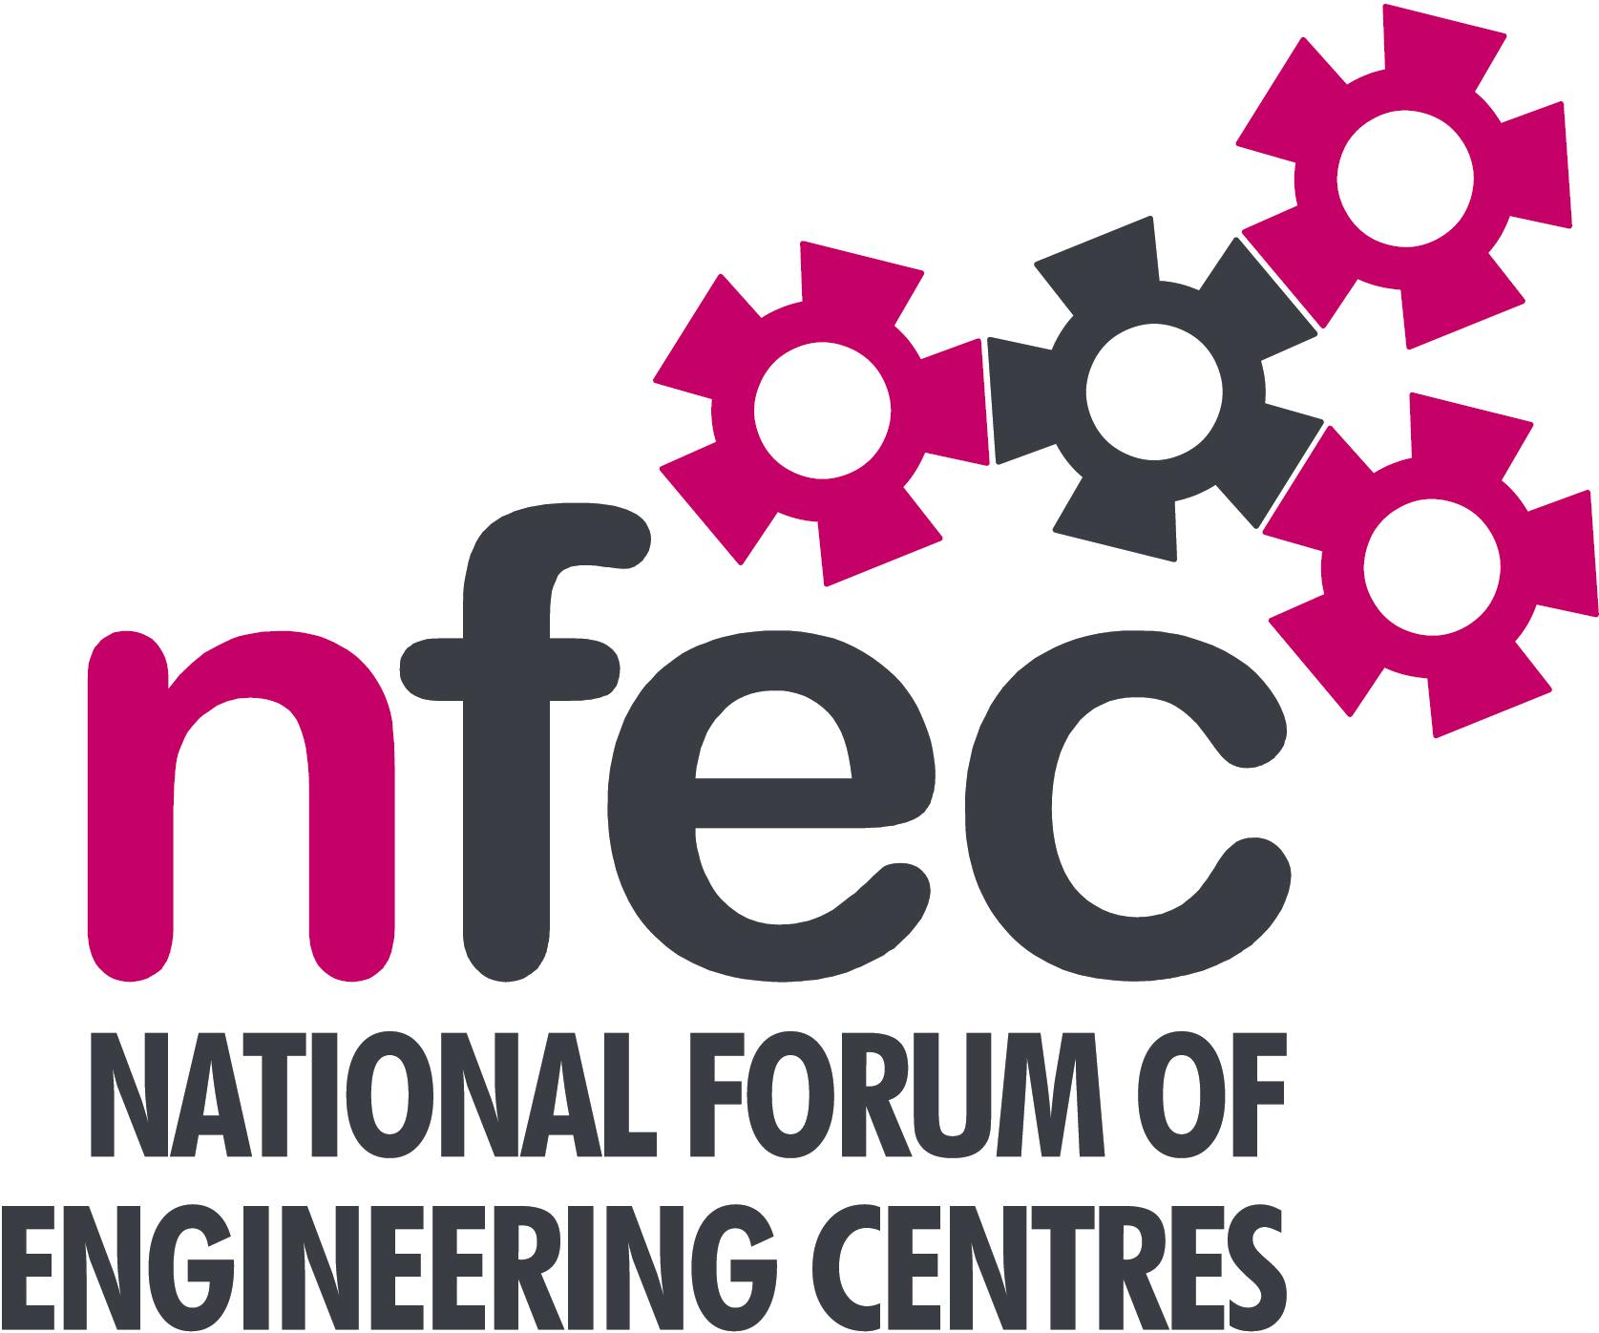
NFEC Spring 2020 North East Regional Seminar
Host: New College, Durham
Chair: John Lockey

Friday 28th February 2020 9.45 – 14.00 (Coffee from 9.30)
Venue: Framwellgate Moor Campus, Durham, DH1 5ES
Telephone: 0191 375 4000

Programme

- Welcome and Introduction to the Seminar and New College  Tour of facilities at New College | John Lockey (NFEC Director and North East Regional Coordinator)  Ian Gaskill, New College and NFEC Director | 9.45
- Qualifications and Awarding Bodies – Current developments and general issues.  Open Round the Table discussions to include:  - T Levels - Update on T Level Developments and related issues  - Ofsted  - End Point assessment  with Lunch and Demonstrations by Exhibitors at 12.00  - Plenary session – Issues to note and agreed actions for NFEC  - Date, Place and Topics for next Seminar  Close  Entry is free to this seminar for members or non-members present for a first attendance.There will be a charge for non members after this for attending future seminars. A light buffet lunch will be provided and you will be able to see/discuss demonstrations of the latest available equipment and facilities for the delivery of learning in Engineering. | Andy Barton, EAL  All Delegates/John Lockey  To book your place:  Email: admin@nfec.org.uk  Phone: 07759 901229 | 10.45  11.00  onwards

